

|  |  |  |  |  |
| --- | --- | --- | --- | --- |
| Year 12 Physics – Test 3 (Task 7)  **Electromagnetism** | | | | |
|  | | | | |
| Name: | | | | |
| **Time allowed**: 50 minutes + 5 mins reading time (at discretion of teacher) | | | | |
| **Section** | Number of questions | Your Mark | Marks available | Percentage of Test |
| **Section One:**  Short answer | 5 |  | 13 | 30 |
| **Section Two**:  Extended answer | 3 |  | 25 | 50 |
| **Section Three:**  Comprehension  and data analysis | 1 |  | 11 | 20 |
|  | **Total** |  | **49** | **100** |

* Final answers should be given up to three significant figures and include appropriate units where appropriate. Questions containing the instruction "ESTIMATE" should be given two significant figures and include appropriate units where applicable.
* Scientific Calculators are allowed.
* No notes allowed.
* Formula sheet is provided.

**Section One:** Short answer

**Question 1 (2 mark)**

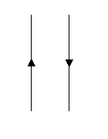  
Two current carrying wires are set up as shown.

* 1. Draw in the field around each wire using ‘x’ or ‘•’. (1 mark)
  2. What will happen to the wires when direct current flows in each wire as shown? (No explanation required.) (1 mark)

_________________________________________________

_________________________________________________

**Question 2 (3 marks)**

Draw the field around the following magnets. (3 marks)

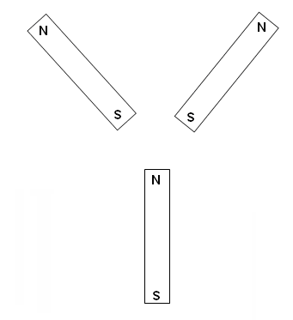

**Question 3 (4 marks)**

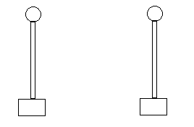

Two metallic spheres are mounted as shown above on insulated rods. The spheres carry charges of 20.0 C and -160.0 C. Their centres of charge are 110.0 mm apart.

a)Calculate the electrostatic force between these spheres including a direction. (2 marks)

_______________**N**   
  
  **Direction** ___________________

b) The spheres are now touched together and returned to their former positions. Calculate the electrostatic force between them now including a direction. (2 marks)

_______________**N**   
  
  **Direction** ___________________

**Question 4 (2 marks)**

A wire carrying a current of 2.25A is placed 15.0cm away from a magnetic field detector. The detector measures the field strength.

Calculate the field strength and therefore the reading on the detector.  
 (2 marks)

_________________ T

**Question 5 (2 marks)**

A mass spectrometer is being used to determine the mass of a doubly ionized argon atom. The argon ions enter the magnetic field with a velocity of 1.71 x 104 m s-1 and follow a path with a 9.40 cm radius. If the magnetic field strength is 5.50 x 10-2 T calculate the mass of an argon ion.

**___________________ kg**

**Section Two:** Extended answer

**Question 1 (9 marks)**

An uncharged drop of oil is given 5 excess electrons. It is then introduced into the space between two horizontal plates 40.0 mm apart with a potential difference between them of 1.75 kV. The drop of oil remains stationary within the Earth’s gravitational field.

* 1. Calculate the magnitude of the electrical field strength between the plates (2 marks)

_______________**V m-1**

* 1. Is the top plate positive or negative? Explain your reasoning. (2 marks)  
       
     ________________________________________________________________________________  
     ________________________________________________________________________________  
     ________________________________________________________________________________  
     ________________________________________________________________________________  
     ________________________________________________________________________________
  2. Calculate the magnitude of the electric force acting on the oil drop. (3 marks)

_______________**N**

* 1. Calculate the mass of the oil drop. (2 marks)

_______________**kg**

**Question 2 (8 marks)**The coil ABCD, which is free to rotate about the axis XY, is placed in a magnetic field of 9.08 mT. The coil consists of 25 turns and a current of 2.20 A is passing through it. The coil is rectangular, with AB = 55.0 mm and BC = 35.0 mm.

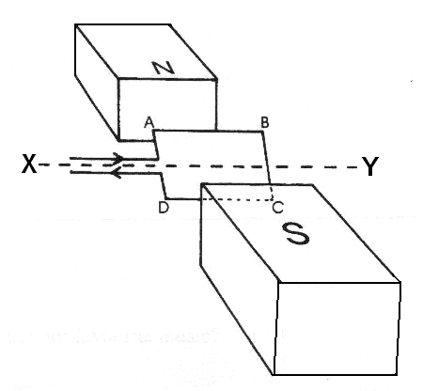

1. Calculate the maximum torque on the motor. (3 marks)

_______________**N m**

1. Give three ways in which the torque could be increased. (3 marks)

________________________________________________________________________

________________________________________________________________________

________________________________________________________________________

1. On the graph below, sketch the torque on the coil as it is rotated through 3600 from being initially horizontal. (2 marks)

τ

θ

**Question 3 (8 marks)**

A transformer is being tested. The primary coil is connected to a battery and a switch. The switch is closed allowing current to flow to the primary coil. An ammeter is connected to the secondary coil and initially deflects to the right then returns to its normal position.

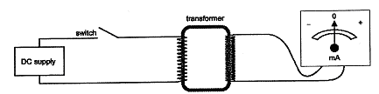

* 1. Explain why the meter needle deflected when the switch is initially closed. (2 marks)  
       
     __________________________________________________________________________

__________________________________________________________________________  
  
__________________________________________________________________________  
  
__________________________________________________________________________

* 1. Explain why the needle returns to the original position even though the switch remains closed. (2 marks)  
     __________________________________________________________________________  
       
     __________________________________________________________________________  
       
     __________________________________________________________________________

__________________________________________________________________________

* 1. A coil has 400 turns with each of the coils having an area of 15.0 cm2. The coil is placed in a magnetic field of flux density 0.800 T. What emf will be induced in the coil if the direction of the magnetic field is reversed in 2.45 s?   
      (4 marks)

_______________**V**

**Section Three:** Comprehension and data analysis

**Alternating Current and RMS values (11 marks)**

A light globe that is plugged into the mains electricity supply of an Australian house is actually switching on and off 100 times per second. This is because the mains electricity is powered by Alternating Current (AC). If current is plotted against time it is a sinusoidal waveform with a frequency of 50 Hz. The light globe will glow at its brightest when current has a maximum magnitude and will momentarily be switched off as the current changes direction.

Alternating current is driven by an alternating emf. For a simple resistance circuit, if emf is plotted against time it also has a sinusoidal form of the same frequency and is in phase with the current. Alternating emf drives charge carriers back and forth along the same piece of conducting wire.



Emf maximum = 340 V $V_{RMS}=\frac{V_{max}}{\sqrt{2}}=\frac{340}{\sqrt{2}}=240 V$

Graph 1 showing alternating emf in an Australian household mains supply

It is difficult to analyse the instantaneous power characteristics of an AC resistance circuit as the values of emf and current are constantly changing. It is more convenient to consider the average power produced over one cycle. This is done by using the Root Mean Square (RMS) values of current and emf.

The RMS equivalent current is defined as the direct current (DC) that will provide the same power in a resistor as AC does on average. The same logic applies for RMS voltages.

The equations to calculate RMS values are: $V_{RMS}=\frac{V_{max}}{\sqrt{2}}$ $I_{RMS}=\frac{I_{max}}{\sqrt{2}}$

Use of the RMS values allows an AC circuit containing only resistors, to be analysed in the same way as a DC circuit.

An AC generator is a source of alternating emf. It can be shown that the maximum emf on the alternating cycle can be calculated using the following equation:

Vmax = maximum emf (V) N = number of turns on coil

A = area of coil (m2) f = frequency of rotation (Hz)

B = magnetic flux density (T)

$$V_{max}=NAB2πf$$

Diagram 1 shows the coil PQRS of an AC generator placed between magnetic poles.

* A uniform magnetic field of flux density 0.126 T exists between the magnetic poles.
* The dimensions of the coil are: PQ = SR = 17.0 cm and PS = QR = 9.00 cm
* The coil rotates about the axle as indicated as a torque is applied to the pulley.
* The coil has 600 turns of wire and is rotated uniformly at 840 rpm.

Contacts to external circuit

Slip rings

Pulley that turns coil

Axle

**P**

**R**

**Q**

**S**

PQ rotates out of page

SR rotates into page

Diagram 1 – AC generator viewed from the top. Coil PQRS sits flat in the magnetic field between the North and South magnetic poles shown.

**S**

**N**

Diagram 2 – The AC generator viewed from the front (location of the slip rings) after coil PQRS has rotated by 20° from the position shown in Diagram 1.

**S**

**N**

Axle

**Questions**

1. Why does the passage state that a light globe switches on and off 100 times per second when the AC frequency is 50 Hz? (1 mark)  
     
   __________________________________________________________________________  
     
   __________________________________________________________________________  
     
   __________________________________________________________________________  
     
   __________________________________________________________________________

__________________________________________________________________________

1. A simple circuit has a resistance of 4.00  and is driven by an RMS voltage of 120 V. Determine the maximum current that will flow through the resistor as part of the AC cycle.  
    (2 marks)
2. Indicate on the Diagram 1, the direction of **conventional** current along PQ and SR as the coil rotates from the position shown. Use arrows and label them ‘current’.  
    (1 mark)
3. Briefly describe how you arrived at your answer for the previous question c. (1 mark)  
     
   __________________________________________________________________________  
     
   __________________________________________________________________________  
     
   __________________________________________________________________________  
     
   __________________________________________________________________________
4. Consider the lengths PQ and RS in the AC generator in Diagram 1. They can each be considered as long straight conductors and the emf generated across them is a maximum when they move in a direction perpendicular to the magnetic field lines. From the starting point of emf = $l$ vB derive the equation $V_{max}=NAB2πf$ showing clear logical steps.  
    (3 marks)

1. Calculate the maximum emf (Vmax) for the AC generator shown in Diagrams 1 and 2. (3 marks)

E**nd of Test**